**TCM Knowledge to Empower Women’s Health**

**A 5 CEU/PDA course by Dr. Harvey Kaltsas, AP, DOM, Dipl. Ac (NCCAOM)**

This course covers the following topics:

* **A.** An overview of preventive health measures for women based on knowledge of Traditional Chinese Medicine (TCM) principles
* **B.** A discussion of cross-cultural attitudes toward birth control
* **C.** An in-depth look at herbal alternatives to use for birth control

**A.** **An Overview of Preventive Health Measures for Women Based on Knowledge of Traditional Chinese Medicine (TCM) Principles**

Nine years ago a 35-year-old woman came to me who was having difficulty conceiving. I diagnosed her as having a deficiency of kidney yin and blood, and I treated her as follows:

* I gave her this herbal formula – *Wu Chi Pai Feng Wan*
* I did acupuncture for Ming Men Deficiency according to Dr. Yoshio Manaka’s *Tokito* protocol as described in his book **Chasing the Dragon’s Tail: copper needle to left PC6, zinc needle to right UB 62, zinc needle to left Sp6, and copper needle to right Lung 7**
* I performed indirect *moxa* bilaterally to Kidney 2
* **I gave her** some advice on timing intercourse in accord with astronomical calculations suggested by the Czech psychologist Eugen Jonas. The latter method may be read on pages 357-365 of Sheila Ostrander’s and Lynn Schroeder’s book, **Psychic Discoveries behind the Iron Curtain**, a copy of which may be read via the following link:

[https://archive.org/details/psychic-discoveries-behind-the-sheila- ostrander/mode/2up](https://archive.org/details/psychic-discoveries-behind-the-sheila-%09%09ostrander/mode/2up)

A year later this patient called to thank me for the help I’d given her, because she had recently given birth to a healthy baby girl.

When I heard from her again it was eight years later. She came in for an appointment, and I could see right away something was wrong. She’s 5’7” and had dropped from 126 pounds to 106 pounds. At age 40 she’d given birth to twins prematurely and thereafter suffered from severe postpartum depression, a condition which persisted until the day of our current visit, despite taking SSRI drugs. Although her husband had a good job and contributed adequate financial support, she otherwise had no help from anyone raising her three children; and initially the two preemies had needed extra care ongoingly, but by now they were “terrors.”

She felt exhausted, had no appetite, and weeped continuously during our session. She also bemoaned the fact that her career as a talented landscape artist was over, and she even felt too tired to be a good mother. I felt her pulses and both the kidney yin and kidney yang pulses were very, very weak. Her extremities were cold, and her tongue was pale and quivering. Clearly she was suffering from blood, qi, and kidney yin and kidney yang deficiencies.

This appointment I treated her once again with acupuncture for *Ming Men* Deficiency: **copper needle to left PC6, zinc needle to right UB 62, zinc needle to left Sp6, and copper needle to right Lung 7.** I also ordered some *Wu Chi Pai Feng Wan* for her, and we rescheduled for a week later.

I told her that her condition was simply kidney yin and yang deficiency and qi and blood deficiency resulting from her blood loss during childbirth, and that once those were replenished, she would be back to her normal, healthy, happy self. I also suggested that she cook up some *koi koku*, which is the traditional Japanese soup consumed for a month after delivery to renourish women and to prevent or to treat postpartum depression.

This is the recipe:

1. Take a whole-1.5 foot-long carp, open it up, and remove the gall bladder as is described later on in this video. <http://cheffingupwithmark.com/youtube-posts/from-market-to-plate-filleting-and-cooking-a-massive-carp-for-traditional-japanese-koi-koku/> I advised her only to pay attention to how to remove the carp’s gall bladder, not the rest of the video which is not the ideal method to prepre *koi koku.*
2. Put the entire carp (minus the gall bladder) into a big pot with maybe 1.5 gallons of water
3. Add 3 or four carrots. Cut off the top part.
4. Add 3 or 4 burdock (*Gobu*) roots. They should be young, soft roots from springtime. Older roots get woody and hard.
5. Cut up and add a few onions
6. Bring to a boil, add *kome* or *mugi miso* (a good bit) and then let simmer for 24 hours.

At the end all the bones, head, organs, and meat of the fish along with all the vegetables will be dissolved into a quite-delicious-soupy mash. Store in the fridge and warm up and eat/drink couple of cups a day. This is a super energizing/revitalizing/re-mineralizing food for any woman, especially one who has just delivered children. I did this for the mother of each of my three kids. It really builds your blood, energy, and vitality.

My patient declined the advice to cook up *koikoku* and instead decided to wait for arrival of the *Wu Chi Pai Feng Wan*. By the follow-up visit this woman reported her appetite was back. She was much cheerier and her pulses had revived a bit. I again treated her with acupuncture for Ming Men Deficiency with a copper needle to left PC 6, zinc needle to right UB 62, zinc needle to left Sp 6, and copper needle to right Lung 7. Plus I did indirect *moxa* bilaterally to Kidney 2, and I also treated her with PhotoBioModulation bilaterally to Kidney 2 for five minutes with 630 nanometer (nm) and 805 nm LED light.

Her next visit was a week later just to pick up her Wu Chi Pi Feng Wan. She was in a much better mood, said she was eating better, and was thrilled to report that she’d just been hired part-time as a docent at our local major art museum. We spoke again by phone five days later when she told me she was feeling happy and healthy, taking her herbs regularly, and looking forward to our next visit. I then sent her a copy of Dr. Zhao’s recommendations for women’s health which follow on the next page in this course.

Six weeks after her initial treatment and a month after starting the *Wu Chi Pai Feng Wan* she sent me the following email:

Dear Harvey,

Thank you for the info and since my daughter is seven I will be following those specs for her, but that’s not why I’m writing.

I am simply dumbfounded by my overall wellbeing since your treatments, way more so than conceiving. I haven’t had energy or happiness in several years despite trying and persevering, waiting for things to work or get better, seeking it in unhealthy ways.

Everyone in the house has had the flu since last week except me. And you KNOW kids be coughing in my face, cleaning up vomit, etc. No small thing since also starting a new job and getting sick the same week would be incredibly disadvantageous!

So my acknowledgment and confirmation is the least I could offer. I stand by my statement that you are a magician, good sir, and thank you.

**I wish that more American women had the benefits of TCM, but, sadly, they do not. Too often women come in to my office with problems from which they had suffered long-term but which are easy to prevent or to treat with traditional Chinese or Japanese medicine. Knowledge is power, and there is much power in knowledge of TCM.**

In that regard, Dr. Ruan Jin Zhao of Sarasota published a gem of TCM knowledge in 2004 called **Menopause, the Correct Way to Deal with It**. Dr. Zhao was one of the very first doctors ever to receive a Ph.D. in Traditional Chinese Herbal Medicine from the People’s Republic of China and is really a master in this field. He graciously permitted me to republish his article herein:

For menstruation to stop at a certain age is a normal physiological occurrence. In Chinese medicine, the physiological stages are defined in seven year segments.

* At age seven, kidney energy is getting stronger, permanent teeth begin to appear, and hair grows longer.
* During the second seven years, *Tian Gui* arrives and the *Ren* meridian opens up, the *Chong* meridian is full of energy, menstruation starts, and childbearing is possible. *Tian Gui* is a pituitary gland hormone and a sexual hormone.
* In the seventh cycle of seven years, a woman’s *Ren* meridian energy drops, and energy in the *Chong* meridian is getting weaker; the *Tian Gui* hormone is no longer produced, and menstruation stops, resulting in an inability to become pregnant.

This clearly illustrates the woman’s physiological cycles, which are dependent on the level of kidney energy and the energy available in the Ren and Chong meridians. Some women have genetically strong kidney energy, and their Tian Gui can last much longer than 49 years. Also, if the kidneys are cared for very well, their Tian Gui may stay longer.

For women, menstruation, pregnancy, and childbirth are natural physiological occurrences, but they are also critical times in a woman’s health. If each step is handled well, the steps following will be easier. Otherwise, problems may be created.

**FIRST STAGE - Menstruation**

From the first menstruation, a woman should pay attention to her periods. During those times, she should not eat much cold food or drink cold beverages. She should not touch cold water or bathe with cold water. The body temperature should be maintained at a relative warm level, which is good for the blood flow. Cold food, drink, and/or bath water can cool the body thus effecting kidney energy and can cause blood stasis and coagulation. If the menstruation blood cannot be completely expelled, it will cause cramping – thereby blocking the energy level. Some women will no longer have periods following that kind of episode.

Also, necessary hygiene care should be remembered, such as:

* no intercourse
* no alcoholic drinks
* no strenuous physical exercise
* no drug interference(some ladies purposely postpone their periods due to certain events in their lives), and
* also no emotional disturbance like anger or stress

In the U.S., this aspect of health education is very poor. Women are told they can do anything they like. Many young women in their puberty are put on birth control pills, which may last for the next ten or fifteen years. All these factors may explain why so many young women are suffering from endometriosis and fibroid diseases. It may also explain why having a hysterectomy is so common in the U.S.

Once a woman has problems with menstruation, it may affect her whole life, and can often lead to infertility. Parents should watch and educate their daughters in these areas.

**SECONDARY STAGE - Pregnancy**

The secondary stage or critical moment for a woman is pregnancy. Right now in this society, most women already know the serious care needed during pregnancy. There is to be no alcohol and no smoking - all the while getting enough nutrients. Maintaining a happy and pleasant mood is also good for the baby’s development and can prevent complications during pregnancy. This point should be addressed by the gynecologist.

**THIRD STAGE – Postpartum most important**

The most important thing and often neglected is postpartum care. As such it is the third most critical moment in a woman’s life. Years ago when I first saw one of my colleagues come back to work after she gave birth to her first baby, I was stunned. How can she stand up and walk around and how can she be back to full-time work in less than one week after delivery? That was unbelievable to me.

In China the new mom will stay in bed for at least two weeks. The baby’s grandmother always takes care of everything including the new baby. After nine months of pregnancy, the body requires at least one month to recover. It is called “*Zuo Yue Zi*.” Due to the stress in society, almost no new mom can get one month of bedrest in the U.S. I truly think this is crucial and not fair to women.

This is the major reason so many women suffer from body aches and joint problems in later years. A mother’s muscle skeletal system, neurological system, endocrine system, and psychological system indeed take time to rebalance. A woman mismanaging her health postpartum will suffer the consequences come the time of menopause.

**FOURTH STAGE – Menopause**

Menopause then is due to a drop in the growth hormone level or low kidney energy. The ovaries stop producing eggs, and at the same time the ovaries will retire from the duty of manufacturing estrogen. Often, women abuse themselves in their youth with too much coffee or adrenal gland stimulants (chocolate, pain medicine, and birth control pills), and/or crazy fitness exercise to keep the body in shape which amounts to body abuse, by exhausting the adrenal glands.

During menopause, the retired ovaries will transfer their function to the adrenal glands, which [when exhausted] have no [longer a] potential ability … to make estrogen, while what they can do and do is to excrete more cortisone from the adrenal cortex. The cortisone causes women to have hot flashes and night sweats or mood swings.

Somehow it reminds me of people taking steroids. In the normal [healthy] physiological situation, men and women have can have estrogen produced by their adrenal glands but in very small amounts. Ovaries and testicles produce the major amount of sexual hormones. But when the ovaries do not need to make eggs or do not need to ovulate, the ability to make estrogen becomes a very dangerous thing. This can cause breast cancer and ovarian cancer. The retirement of the ovaries from making estrogen reduces the risk of cancer. It is natural to transfer that duty to the adrenal glands.

## Author HK’s note here: How Do Adrenal Glands Compensate for Decreased Estrogen?

As mentioned earlier, during menopause or when ovarian function decreases due to age or medical conditions, adrenal glands become increasingly important in hormone production. The adrenal cortex converts androgens into estrogens through a process called aromatization.

This conversion process allows for a more consistent supply of estrogen even when ovarian production wanes. It’s fascinating how adaptable our bodies can be! However, it's essential to note that while adrenal glands can produce estrogen during menopause or when ovaries are not functioning optimally, they do not produce it at the same levels as healthy ovaries would.

This compensatory mechanism highlights the importance of maintaining healthy adrenal function throughout life. Stress management techniques such as meditation or yoga may support adrenal health by reducing cortisol levels and allowing for better hormone balance.[1]

**TEACH THE ADRENAL GLANDS**

This theory can be understood and supported by the physiology text book and by clinical practice. I have observed many patients who have not taken any hormone replacement after a total hysterectomy. They do not have any clinical symptoms such as hot flashes and night sweats. Surprisingly they still have beautiful skin and a normal libido. They do not have a dry vagina and their bone density is good.

So based on this theory, it is absolutely wrong to suppress the adrenal glands function and inhibit the flow of cortisone. The major thing is to teach the adrenal glands to excrete estrogen and not cortisone. It takes time for the adrenal glands to learn the new trick, about 3-4 months. So black cohosh, aloe vera, and remefeine [Remifemin][2] are the wrong substances to use because these remedies belong to the adrenal gland suppressor [category]. It is fine to use them temporarily, but if taken continuously, the long term result will not satisfy the patient. These cold remedies may upset the patient’s stomach. They can also produce weight gain due to the lack of cortisone and slow down of the body’s metabolism, which is the outcome most women dislike.

The correct remedy should be adrenal gland cultivators such as *Dang Gui* (Chinese Angelica root), *Di Huang* (Rehmannia root, *Huang Ling* (Sichuan Solomon root), *He Shou Wu* (Fleece Flower root), *Shan Yu Rou* (Dog Berry), *Gou Qi Zi* (Wolfberry), *Sang Shen Zi* (Mulberry), and *Fu Pen Zi* (Raspberry)- to let the adrenal glands gain more strength and work smarter.

Definitely we should avoid overuse of adrenal gland stimulants such as coffee and chocolate, which can aggravate the hot flashes and night sweats. Menopause starts from the kidney essence dropping, so it is logical to increase the kidney essence with herbal remedies. When kidney essence is recovered, the adrenal glands can produce more estrogen and less cortisone; the hot flashes, night sweats, and mood swings will naturally diminish. In Chinese medicine, we call it treating the root cause.

**In general, women should pay attention to each critical physiological moment.** Then when menopause comes, it will be much easier. Even if women do not feel any symptoms and go through the life change naturally, prevention is always better than treatment.

**THANK YOU, Dr. R.J. ZHAO!**

Honora Lee Wolfe covers many of the same points in her excellent book, **Second Spring, A Guide To Healthy Menopause Through Traditional Chinese Medicine.** Itshould be must-reading for every American woman as she ages.

Here are a few other tips for women’s health. To prevent breast cancer, take potassium iodate daily – unless you suffer from the Hashimoto’s thyroid auto-immune disorder. Japanese women average 12 mg. of iodine intake a day, mostly from eating fish and seaweed. You can get 12.5 mg. of iodine day from one Iodoral capsule or tablet, easily available from many sources online. Potassium iodate also works very well against fibrocystic breast disease, both preventing and treating it. You can learn much more about the benefits of iodine, especially for breast health, by downloading for free my CEU course **Lab tests – Urinalysis and Iodine Levels** at <https://hkacup.com/product/lab-tests-urinalysis-iodine-levels/>

Two other important nutrients for breast health are blueberries, particularly wild blueberries such as Wyler’s from Maine frozen Wild Blueberries. A 2020 study showed that two servings of blueberries a week significantly lowered incidence of breat cancer.[3]

Also, daily intake of 200 micrograms of selenium (micrograms, not milligrams – selenium intake beyond a microgram level can be very toxic!) is also quite helpful for preventing breast cancer.[4] [5] A food source of selenium is the Brazil nut. Each Brazil nut averages 68 micrograms of selenium[6], so three a day are plenty! Don’t eat too many. Regular bingeing on Brazil nuts is a definite no no.

**B.** **A Discussion of Cross-Cultural Attitudes toward Birth Control**

In 1970, while studying with the Japanese macrobiotic teacher Michio Kushi and the acupuncturist Dr. Nakamura, I learned that the preferred method of birth control in Japan – by 70% - was the use of condoms. Why? I was taught this was so because the Japanese respected women’s health and that condoms had little adverse effect on a woman’s biology. I also read that in 2004 condoms were used as the primary method of birth control 80% of the time, partly because Japanese women shunned birth control pills.[7] I am heartened by this cultural attitude of trying to protect women’s health and wish that were a prevalent zeitgeist in American society. Unfortunately, male condoms alone are not a sure-fire way to prevent pregnancy, since the US Centers for Disease Control documents this method has a 13% failure rate!

Condom use aside, all was not rosy in Japan regarding birth control in Japan. Throughout the 19th and early 20th centuries, Japanese women were discouraged from having babies, and birth control was effectuated primarily through abortion and by infanticide, usually by suffocating newborn babies.

*“A typical method in Japan was smothering the baby's mouth and nose with wet paper. It became common as a method of population control. Farmers would often kill their second or third sons. Daughters were usually spared, as they could be married off, sold off as servants or prostitutes, or sent off to become*[*geishas.*](https://en.wikipedia.org/wiki/Geisha)[*””*](https://en.wikipedia.org/wiki/Birth_control_in_Japan#cite_note-4)*[8]*

However, before World War Two there had been a big push for women to have more babies, because the army wanted more prospective troops; but after the war there was a decided push toward contraception, especially with condoms, diaphragms, and birth control education.[9] Birth control pills were not in use at all until just before the turn of the 21st century. Low-dose birth control pills were not legalized in Japan until 1999, and then only when concurrent with the legalization of Viagra![10] Full-dose birth control pills were legalized in 2011, but are by prescription only.

In China, conversely, birth control has been achieved partly by injections of isolated proteins from the abortifacient herb trichosanthes, *Gua Lou*,[11] partly by sterilization (sometimes forced), and largely by *rengong lichuan* (man-made miscarriage or surgical abortions). By 2015 there were 13 million abortions performed each year in China,[12] and now that has leveled off to about 9 million abortions a year. By 2013, under the Chinese Communist Party’s family planning policies, there were 330 million abortions performed in China,[13] many forced. Abortions based on sex selection has resulted in a deficit of 60 million women in the current Chinese population, and Trump adviser Stephen K. Bannon regularly reports on his War Room podcast that there have been 400 million abortions in communist China to date.[14]

……………………………………………………………………………………

Conversely, in many of our United States, legal restrictions on abortion limit women’s choices when it comes to reproduction. In Florida, there is a prohibition on access to abortion for women who are more than six weeks pregnant – Florida law **Chapter 390.0111 Termination of pregnancies.**. For many of my own female patients, friends, and relatives, six weeks without a period can be a routine occurrence and does not signal the start of a pregnancy. With this in mind, we practitioners need to find ways to offer our female patients additional knowledge about their body and practical, safe, and harmless approaches to assert their reproductive rights. We practitioners need to inform women how to support their health overall health and to counsel those who fear they may become or have become pregnant on the various modes of birth control, including herbal methods.

On the wall of my office is a copy of a painting from 1,400 B.C., excavated at Knossos, Crete, of two nimble Minoan women engaged in the sport of bull-jumping. It’s a pretty daring athletic event, and they are of necessity dressed in functional clothing appropriate for the occasion, but that some today would consider too scanty. What strikes me when I look at those women is how free, courageous and empowered they were, in stark contrast to the conditions that many 21st century women must endure.

Now, 3,400 years later, effective November 24, 2024, women living in Libya, which is just 212 miles south of Knossos, are subject to the clothing dictates of the “morality police” and must wear veils in public. Moreover, women’s travel without a male guardian is now restricted, and gender mixing in public spaces is prohibited. What the hell happened in the past 34 centuries to so constrain the rights of these Libyan women?

Abortion rights in Libya? They are not allowed for any of the following reasons: economic or social, fetal impairment, rape, incest, intellectual or cognitive disability of the woman, mental health, or physical health. Penalties for abortions are applied to the women getting abortions, even if the abortions are non-consensual (!), to the provider, and to anyone who assists.

A bit further east, in Saudi Arabia, women are under even more severe restrictions, and in Afghanistan, women are totally suppressed. However, many Muslim countries do permit abortion, and several sects (Hanafi among the Sunni and the Shia) do not consider a pregnancy to begin until implantation of the fertilized egg into the uterus. “All Islamic schools of thought agree abortion is recommended when the mother's life is in danger, because the mother's life is paramount.” [15]

The simple facts are that

* a woman wants power to control her own body
* knowledge is the ultimate source of power.

Over millennia, suppressing knowledge has been the prime strategy used to suppress women. It’s been a sad history, one eloquently chronicled in the magnificent book by Barbara Ehrenreich and Deirdre English: **Witches, Midwives, and Nurses, a History of Women Healers**, which is now available to read in full on the web at

<https://www.marxists.org/subject/women/authors/ehrenreich-barbara/witches.htm>

[None of the contents of this book will be on the exam associated with this course. It appears strictly for the reader’s enlightenment.]

Ironically, before the Christian era, women knew a great deal about how to care for their bodies, and specifically they knew about herbal approaches to birth control. In this course, we will discuss some of these methods. Some may have moral qualms about abortion. Nothing which follows is about abortifacients nor does the knowledge presented breach the Hippocratic oath, “To do no harm.” Here is the relevant portion of his oath:

**"…With regard to healing the sick, I will devise and order for them the best diet, according to my judgment and means; and I will take care that they suffer no hurt or damage.**

**“Nor shall any man's entreaty prevail upon me to administer poison to anyone; neither will I counsel any man to do so. Moreover, I will give no sort of medicine to any pregnant woman, with a view to destroy the child.”**

In fact, Hippocrates, the Greeks, and the Hebrews were well aware of herbal ways to prevent birth that were not abortifacients. How to prevent a pregnancy after a woman has had her egg fertilized without causing an abortion? How to square that circle?

Hippocrates’ view was that pregnancy does not occur upon fertilization of an egg by a sperm in the fallopian tube but rather upon implantation of the fertilized egg into the uterus. That’s when an embryo starts to grow. Hippocrates recommended that women drink copper laden water to prevent pregnancy, and he said that method could be effective for up to a year.[16] In modern times we have come to learn that copper disrupts the movement of sperm and prevents implantation of a fertilized egg into the uterus.[17]

Other Greeks, Romans, Egyptians, and ancient Minoans used Silphium as their contraceptive of choice.

“They used this fennel-like plant to ease bloated stomachs, season their food, perfume their bodies, and prevent pregnancy. For six centuries, women drank the plant’s heart-shaped seeds as some form of juice once a month for a natural contraceptive. Women also put wool [soaked](https://www.damninteresting.com/the-birth-control-of-yesteryear/) in the plant’s juice into their vaginas to prevent pregnancy. Silphium (also called laserwort) was valuable and important to the ancient Mediterranean trading economy, and Cyrenians put an image of a silphium seed on their currency.

“Scholars don’t know how silphium worked or how effective it was as a contraceptive—one 1985 study found that the extract of a likely relative of silphium prevented rat pregnancies when administered orally, and yet the same dosages were ineffective in hamsters—but the contraceptive plant may have [contributed](http://www.nytimes.com/1994/03/08/science/in-ancient-times-flowers-and-fennel-for-family-planning.html?pagewanted=all) to Rome’s low birth rate. Ancient farmers were unable to cultivate silphium—it only grew near Cyrene, in present-day North Africa—and the plant went extinct between the 1st and 2nd centuries CE.” [18]

Columbia University Irving Medical Center reports that:

The [fertilized] egg takes several days to travel down the fallopian tube into the uterus. After it is in the uterus, a fertilized egg usually attaches to (implants in) the lining of the uterus ([endometrium, Opens dialog](https://www.columbiadoctors.org/health-library/definition/endometrium/)). But not all fertilized eggs successfully implant. If the egg is not fertilized or does not implant, the woman's body sheds the egg and the endometrium. This shedding causes the bleeding in a woman's menstrual period.

When a fertilized egg does implant, a hormone called human chorionic gonadotropin (hCG) begins to be produced in the uterus. This is the hormone that a pregnancy test measures. It prevents the uterine lining from being shed, so the woman does not have a period. Other signs such as breast changes and nausea occur in a woman's body, also meaning that pregnancy has begun.

So, is a woman actually pregnant when one of her eggs is fertilized or when that fertilized egg implants into the uterus which causes production of hCG? Which is it? Hippocrates thought the latter, which is how for birth control he rationalized prescribing herbs or copper which prevented implantation. He specifically opposed using pessaries and/or abortifacients to purged an embryo from the uterus – this is what he considered to be an abortion.

A question remains for many of the Christian faith: Does not human life start at conception - when a sperm fertilizes the egg? Does not the human soul enter the fertilized egg at that moment? Many answer that question with a resounding yes, which is why they consider the morning after pill to be an abortifacient, that is, something which causes an abortion.

My own personal reasoning on this matter is as follows. All Christians I know say that God is perfect and incapable of making mistakes, that the human soul is unique, and there is one human soul for one human body. Given that line of reasoning, how does one explain twins, triplets, and quadruplets? If one soul is infused into one fertilized egg at the moment of conception, where and when does the fertilized egg containing one soul split and gain access to other souls? These are questions I cannot answer, and many cultures resolve this by saying the human soul enters the fertilized egg at a later date. I personally think this occurs when or after pregnancy occurs (as defined by when a fertilized egg implants into the uterus).

**What about birth control in the Hebrew tradition?**

Well before the start of the Christian era, the Bible contained advice for women on birth control. In the March 21, 2023 issue of *Lessons from History,* Savannah Carreno observes:

# *“Esther used contraception. And so did most women in the Bible (*gasp)”*

Book of Esther, Chapter 2:

[**12** Now when every maid's turn was come to go in to king Ahasuerus, after that she had been twelve months, according to the manner of the women, (for so were the days of their purifications accomplished, to wit, six months with oil of myrrh, and six months with sweet odours, and with other things for the purifying of the women;)](https://www.kingjamesbibleonline.org/Esther-2-12/)

*“ Esther, we see the women being considered for the King to go through a lengthy preparation process which includes being prepared with ointments, particularly myrrh.*

*“Myrrh — a known contraceptive of the time. We see myrrh used in Esther to prep women for their time with the king… because the last thing the king wants is for all his royal monies to be sapped up by child support. Just kidding we know it's because the king could only marry and procreate with the princely family, of which these concubines were not part of.*

*“The phrase used to describe the process of prepping the women is seen only one other time in the Bible, used to describe the medical embalming of Jacob in Genesis. Suggesting that this is a medicinal process not done by physicians, this 12-month treatment is done by women. Herbal contraception was knowledge possessed and passed down by women quite literally called*dat ha nashin: *the practice of women.*

*“Why was this preparation 12 months long — some scholars suggest it coincided with the female menstrual cycle others suggest it was an effort to introduce the contraceptives at a lower dose over long period of time instead of the toxic high dosage all at once in order to be safe and more effective.*

*“Not to mention the story of Esther mirrors a Greek mythology story of a goddess named Myrrah (yes…like myrrh) who was trapped in an incestual relationship with her father and turned herself into a myrrh tree to escape being impregnated by her father… emphasizing the use and efficiency of the contraceptive in preventing pregnancy.*

*“ Birth-control was not only in the bible but was considered a complex and revered method passed down through generations of women in an effort to protect themselves and their future. If a woman got impregnated by a man who was not her husband, she could be killed.*

*“Or ostracized from the community. If a family had too many kids, they risk starvation or having to sell off kids or land to make enough money to survive. There were no food stamps or deferred loans. Roman soldiers came to collect and if you didn’t pay up, you suffered.*

*“Having kids in antiquity was extremely dangerous. Research suggests there were about 25 maternal deaths for every 1,000 live births. And 300 infant deaths for every 1,000 live births. Not great odds. Women risked their lives to bring life into this world. And their deep network of knowledge surrounding contraception and abortion insured they did so on their terms as often as they could.”*

What is myrrh from a traditional Chinese medical perspective? It’s none other than *Mo Yao*. Its main actions are that it moves the blood, assists in wound healing, relieves stagnation, and mitigates pain caused by stagnation of blood. Contraindications are that it should not be used by pregnant women nor should it be used for long periods of time. All this corresponds to the perspective expressed by Savannah Carreno.

**So where are we today in America?**

What follows are the methods of contraception and birth control recognized by the United States government. Note that no mention is made of any herbal approaches. We will discuss some of these herbal alternatives to conclude this course.

The following article is taken directly from the CDC: <https://www.cdc.gov/contraception/about/index.html>

# Contraception and Birth Control Methods[19]

# At a glance

* Below is information for you on the different kinds of birth control methods.

## Birth control methods

A person might consider different things when choosing a contraceptive method. These include safety, effectiveness[1](https://www.cdc.gov/contraception/about/index.html#cdcreference_1), availability (including accessibility and affordability), side effects, user control, reversibility, and ease of removal or discontinuation. Contraceptive methods should be chosen through voluntary, informed choice.

Most contraceptive methods do not protect against sexually transmitted infections (STIs), including human immunodeficiency virus (HIV) infection. Using condoms (alone or with another contraceptive method) can help to protect against HIV and other STIs. Also, pre-exposure prophylaxis (PrEP) can help to protect against HIV. For more information on STI/HIV prevention visit: [How to Prevent STIs](https://www.cdc.gov/sti/prevention/index.html) and [Preventing HIV](https://www.cdc.gov/hiv/prevention/index.html).

## Reversible methods of birth control

### Intrauterine Contraception

|  |  |
| --- | --- |
| **IUD** | **Levonorgestrel intrauterine system (LNG IUD)—**The LNG IUD is a small T-shaped device like the Copper T IUD. It is placed inside the uterus by a doctor. It releases a small amount of progestin each day to keep you from getting pregnant. The LNG IUD stays in your uterus for up to 3 to 8 years, depending on the device. Typical use failure rate: 0.1-0.4%.[1](https://www.cdc.gov/contraception/about/index.html#cdcreference_1)  **Copper T intrauterine device (IUD)—**This IUD is a small device that is shaped in the form of a “T.” Your doctor places it inside the uterus to prevent pregnancy. It can stay in your uterus for up to 10 years. Typical use failure rate: 0.8%.[1](https://www.cdc.gov/contraception/about/index.html#cdcreference_1) |

### Hormonal Methods

|  |  |
| --- | --- |
| **birth control implant** | **Implant—**The implant is a single, thin rod that is inserted under the skin of a women’s upper arm. The rod contains a progestin that is released into the body over 3 years. Typical use failure rate: 0.1%.[1](https://www.cdc.gov/contraception/about/index.html#cdcreference_1) |
| **shot** | **Injection or “shot”—**Women get shots of the hormone progestin in the buttocks or arm every three months. The shot can be self-injected or given by a health care provider. Typical use failure rate: 4%.[1](https://www.cdc.gov/contraception/about/index.html#cdcreference_1) |
| **oral contraception** | **Combined oral contraceptives—**Also called “the pill,” combined oral contraceptives contain the hormones estrogen and progestin. It is prescribed by a doctor. A pill is taken at the same time each day. If you are older than 35 years and smoke, have a history of blood clots or breast cancer, your doctor may advise you not to take the pill. Typical use failure rate: 7%.[1](https://www.cdc.gov/contraception/about/index.html#cdcreference_1)  **Progestin-only pill—**Unlike the combined pill, the progestin-only pill (sometimes called the mini-pill) only has one hormone, progestin, instead of both estrogen and progestin. It is prescribed by a doctor. It is taken at the same time each day. It may be a good option for women who can’t take estrogen. Typical use failure rate: 7%.[1](https://www.cdc.gov/contraception/about/index.html#cdcreference_1) |
| **birth control patch** | **Patch—**This skin patch is worn on the lower abdomen, buttocks, or upper body (but not on the breasts). This method is prescribed by a doctor. It releases hormones progestin and estrogen into the bloodstream. You put on a new patch once a week for three weeks. During the fourth week, you do not wear a patch, so you can have a menstrual period. Typical use failure rate: 7%.[1](https://www.cdc.gov/contraception/about/index.html#cdcreference_1) |
| **Ring** | **Hormonal vaginal contraceptive ring—**The ring releases the hormones progestin and estrogen. You place the ring inside your vagina. You wear the ring for three weeks, take it out for the week you have your period, and then put in a new ring. Typical use failure rate: 7%[1](https://www.cdc.gov/contraception/about/index.html#cdcreference_1) |

### Barrier Methods

|  |  |
| --- | --- |
| **Diaphragm** | **Diaphragm or cervical cap—**Before sexual intercourse, the diaphragm or cap is inserted in the vagina with spermicide to block or kill sperm. These methods are prescribed by a health care provider. Typical use failure rate for the diaphragm: 17%.[1](https://www.cdc.gov/contraception/about/index.html#cdcreference_1) Typical use failure rate for the cervical cap: 22%.[1](https://www.cdc.gov/contraception/about/index.html#cdcreference_1)  **Sponge—**The contraceptive sponge contains spermicide and is placed in the vagina where it fits over the cervix. The sponge works for up to 24 hours and must be left in the vagina for at least 6 hours after the last act of intercourse, at which time it is removed and discarded. Typical use failure rate: 17%.[1](https://www.cdc.gov/contraception/about/index.html#cdcreference_1) |
| **male condom** | **Male condom—**[External (male) condoms](https://www.cdc.gov/condom-use/resources/external.html) help prevent sperm from entering a partner's body. Latex condoms, the most common type, also help prevent HIV and other STIs. "Natural" or "lambskin" condoms help prevent pregnancy, but may not provide protection against STIs, including HIV. Condoms are available over the counter. Typical use failure rate: 13%.[1](https://www.cdc.gov/contraception/about/index.html#cdcreference_1) |
| **female condom** | **Female condom—**[Internal (female) condoms](https://www.cdc.gov/condom-use/resources/internal.html) help prevent pregnancy by blocking sperm from getting to the egg. It is packaged with a lubricant and is available over the counter. It can be inserted up to 8 hours before sexual intercourse. Internal (female) condoms might help prevent STIs. Typical use failure rate: 21%.[1](https://www.cdc.gov/contraception/about/index.html#cdcreference_1) |
| **spermicide** | **Spermicides—**These products include spermicides and vaginal pH regulators and work by killing sperm or making it difficult for sperm to reach the egg. They come in several forms—foam, gel, cream, film, suppository, or tablet. They are placed in the vagina no more than 1 hour before intercourse. They are left in place at least 6 to 8 hours after intercourse. Spermicide can be used with an external (male) condom, diaphragm, or cervical cap. They can be purchased over the counter or prescribed by a health care provider. Typical use failure rate: 21%.[1](https://www.cdc.gov/contraception/about/index.html#cdcreference_1) |

### Fertility Awareness-Based Methods

|  |  |
| --- | --- |
| **fertility awareness-based methods** | **Fertility awareness-based methods—**Understanding your [monthly fertility pattern](https://www.womenshealth.gov/pregnancy/you-get-pregnant/trying-conceive) can help you plan to get pregnant or avoid getting pregnant. Your fertility pattern is the number of days in the month when you are fertile (able to get pregnant), days when you are infertile, and days when fertility is unlikely, but possible. If you have a regular menstrual cycle, you have about nine or more fertile days each month. If you do not want to get pregnant, you do not have sex on the days you are fertile, or you use a barrier method of birth control on those days. Failure rates vary across these methods.[1](https://www.cdc.gov/contraception/about/index.html#cdcreference_1) Range of typical use failure rates: 2-23%.[1](https://www.cdc.gov/contraception/about/index.html#cdcreference_1) |

### Lactational Amenorrhea Methods

|  |  |
| --- | --- |
| **lactational amenorrhea method** | Breastfeeding can be used as birth control (called **Lactational Amenorrhea Method** or LAM) when three conditions are met: (1) amenorrhea (not having any menstrual periods after delivering a baby), (2) fully or nearly fully breastfeeding, and it is (3) less than 6 months after delivering a baby. LAM is a temporary method of birth control, and another birth control method should be used when any of the three conditions are not met. |

### Emergency Contraception

|  |  |
| --- | --- |
| **Emergency contraception is not a regular method of birth control. Emergency contraception can be used after no birth control was used during sex, or if the birth control method failed, such as if a condom broke.** | |
| **emergency contraception** | **Copper IUD—**The copper IUD can be inserted within 5 days of unprotected sex.  **Emergency contraceptive pills—**Emergency contraceptive pills can be taken up to 5 days after unprotected sex, but the sooner the pills are taken, the better they will work. There are three different types of pills that can be used for emergency contraception. Some emergency contraceptive pills are available over the counter, and some are available only by prescription within the United States. |

#### The Cleveland Clinic reports the following about emergency contraceptive pills:

#### “Levonorgestrel morning-after pills

Pills containing levonorgestrel (a type of [progestin](https://my.clevelandclinic.org/health/treatments/24838-progestin)) work best when you take it within three days (72 hours) of unprotected sex. They’re available to purchase anytime at most drug stores. There are several brands you can buy, and the prices vary, but they all work the same way.

Common brands include:

* Plan B One-Step®.
* My Choice™.
* Option 2®.
* Take Action™.
* Aftera®.
* Preventeza™.

#### Ulipristal acetate

Pills containing [ulipristal acetate](https://my.clevelandclinic.org/health/drugs/19486-ulipristal-tablets) work for up to five days (120 hours) after unprotected sex. It’s only available with a prescription. (You can fill the prescription and save it for when you need it.) The most common brand name for this medication is ella®

… There are side effects, though. Some symptoms of taking a morning-after pill can include:

* Changes to your normal [menstrual cycles](https://my.clevelandclinic.org/health/articles/10132-menstrual-cycle) (your period might be earlier or later than normal)
* Light [vaginal bleeding](https://my.clevelandclinic.org/health/symptoms/17899-vaginal-bleeding) (spotting)
* [Nausea and vomiting](https://my.clevelandclinic.org/health/symptoms/8106-nausea--vomiting)
* Tiredness ([fatigue](https://my.clevelandclinic.org/health/symptoms/21206-fatigue))
* [Headaches](https://my.clevelandclinic.org/health/diseases/9639-headaches) and [dizziness](https://my.clevelandclinic.org/health/symptoms/6422-dizziness)
* Breast tenderness
* [Pain or cramping in your abdomen](https://my.clevelandclinic.org/health/symptoms/4167-abdominal-pain)

The side effects of the morning-after pill are mild for most people. But if you notice more severe symptoms or have concerns after taking the morning-after pill, reach out to your healthcare provider.

## Permanent methods of birth control

|  |  |
| --- | --- |
| **male and female permanent contraception** | **Tubal surgery or “tying tubes”—**The fallopian tubes are tied (or closed) or cut so that sperm and eggs cannot meet for fertilization. The procedure can be done in a hospital or in an outpatient surgical center. The patient can go home the same day of the surgery and resume normal activities within a few days. This method is effective immediately. Typical use failure rate: 0.5%.[1](https://www.cdc.gov/contraception/about/index.html#cdcreference_1)  **Vasectomy—**This procedure is done to keep sperm from going to the penis, so the ejaculate never has any sperm in it that can fertilize an egg. The procedure is typically done at an outpatient surgical center. The patient can go home the same day. Recovery time is less than 1 week. After the operation, it is important to visit a health care provider to make sure the sperm count has dropped to zero; this takes about 12 weeks. Another form of birth control should be used until the sperm count has dropped to zero. Typical use failure rate: 0.15%.[1](https://www.cdc.gov/contraception/about/index.html#cdcreference_1) |

**Abortion pills:** Planned Parenthood also gives instruction on how to have a medication abortion using mifepristone followed by misoprostol. Here’s a link to Planned Parenthood’s video which explains that process:

https://www.plannedparenthood.org/learn/abortion/the-abortion-pill

**What natural methods may a woman use to prevent ovulation and/or implantation of a fertilized egg?**

### In 2012 the Journal of Ethnopharmacology published a comprehensive survey of research studies that had been done on herbs which had antifertlity effects on women. The findings of this comprehensive analylsis - D. Kumar et al. / Journal of Ethnopharmacology 140 (2012) 1–32 - are summarized as follows:

### *“Results: 577 plant species belonging to 122 families, traditionally used in fertility regulation in females, have been recorded, of which 298 plants have been mentioned as abortifacients (42%), 188 as contraceptives (31%), 149 as emmenagogues (24%), and 17 as sterilizers. Among 122 plant families, fabaceae constitutes 49.2%, asteraceae 40.98%, euphorbiaceae 19.7%, apiaceae 16.4%, poaceae 12.3%, labiateae 11.5%, and others in lesser proportion. Various plant parts used in fertility regulation include leaves (25%), roots (22%), fruits (15%), seeds (12%), stem/stem bark (37%), and flowers (4%). Some active compounds, isolated from about various plant species, have been reported to possess significant antifertility potential[20] in the following various ways:*

* ***abortifacients are herbs which provoke abortions***
* ***contraceptives prevent conception either by interfering with implantation of fertilized eggs [or restricting ovulation]***
* ***emmenagogues which promote menstrual flow, regulate the menstrual cycle, and relieve dysmenorrhea or menstrual pain.”***

The database from this report is to be found in the Appendix to this course.

We obviously do not have time to go over all 577 herbs or even just the 188 contraceptive herbs. However, I have extracted references to all the contraceptive herbs in the 2012 **Ethnopharmacology** survey and listed them in the Appendix which follows. The reader can satisfy his or her curiosity simply by copying any or all of these references, putting them into Google, and seeing what comes up.

For example, putting the following herb citation into Google’s search engine – [80] Artemisia vulgaris Linn. [Asteraceae] Nagadouna LF, RT C India Ghosh (2008) – led to several other studies about artemisia vulgaris, our beloved mugwort or *moxa*, “the mother of herbs.” One yielded the following information[21]:

Owing to its extensive distribution, *A. vulgaris* was distinguished in earliest Greece, Egypt and Rome. Its name is taken from the Greek idol Artemis, who is the supporter of expecting women and new mothers. Isis, Artemis and Diana are the goddesses worshipped. *A. vulgaris* was important in religious rites since of its favorable effects on menstruation and pregnancy-related diseases. Reported therapeutic qualities of this species in remedial work were labeled as initial as the earliest century A.D.

Please understand, the 2012 **Journal of Ethnopharmacology** review was not exhaustive, and there are many other herbal formulations used by indigenous peoples to control contraception. For example, the Temuan aboriginals of Malaysia employ the following combination of herbs to restrict ovulation: *Lepidagathis longifolia, Palaquium sp* and *Phyllagathis rotundifolia*.

Scientists in 2007 studied why and how this remedy works and affirmed the intuitive and experiential wisdom of the Temuan natives in the following study:

Malays J Med Sci

. 2007 Jan;14(1):23–27.

# Effects of an Indigenous Contraceptive Herbal Formulation on Gonadotrophs of the Pituitary Gland of the Rat

[Mohd Nazrul Islam](https://pubmed.ncbi.nlm.nih.gov/?term=%22Islam%20MN%22%5BAuthor%5D) *,✉, [Siti Amrah Sulaiman](https://pubmed.ncbi.nlm.nih.gov/?term=%22Sulaiman%20SA%22%5BAuthor%5D) *, [Marina Y Kapitonova](https://pubmed.ncbi.nlm.nih.gov/?term=%22Kapitonova%20MY%22%5BAuthor%5D) *, [Syed Mohsin Sahil Jamallullail](https://pubmed.ncbi.nlm.nih.gov/?term=%22Jamallullail%20SMS%22%5BAuthor%5D) **

* Author information
* Article notes
* Copyright and License information

PMCID: PMC3351214  PMID: [22593648](https://pubmed.ncbi.nlm.nih.gov/22593648/)

## Abstract

An indigenous contraceptive herbal formulation consisting of a mixture of Lepidagathis longifolia, Palaquium sp and Phyllagathis rotundifolia is being used by the Temuan Aborigins of Malaysia. Although the previous studies demonstrated that this contraceptive herbal formulation causes anovulatory estrous cycle, altered circulating hormone levels and fetal resorption in rats, but the effects of this formulation on the gonadotrphs of the pituitary gland are yet to be evaluated. The present study was designed to observe the morphometric changes of the gonadotrophs and the plasma concentrations of follicle stimulating hormone and leutinizing hormone. Thirty five Sprague-Dawley adult female rats were randomly divided into 5 groups. Experimental animals were given a combined herbal extract or individual herbal extract at a dose of 540 mg/kg/day subcutaneously for 7 days. Immunostained gonadotrophs were studied by using image analyzer. FSH and LH serum concentrations were determined using RIA. The FSH and LH concentrations were low in animals that received combined herbal extract (p<0.01). FSH concentration was noted to be significantly low in animals that received P. rotundifolia (p<0.05). The mean cell area and cell density of gonadotrophs of animals that received combined herbal extract were significantly low compared to control group (p<0.05). It was concluded that the herbal extracts do suppress the production of gonaotrophins along with the demonstrable suppresive effect on the FSH cells.

**A Simpler, More Practical Herbal Approach to Contraception:**

**Using the Seeds of Queen Anne’s Lace**

Of course I do not expect anyone to become an expert in ethnobotanical approaches to birth control by taking this course. We are all just looking for ways to assist our patients, especially those who for whatever reason may fear that they may have experienced a potentially-fertilizing-sexual event. If they are averse to taking any of the morning-after pills listed above, using the medication abortion pills mifepristone and misoprostol, or going for an in-clinic abortion, I have personally found using Queen Anne’s Lace seeds to be safe and effective with my patients, an admittedly small sample size.

However, the certified professional midwife Molly Dutton-Kenny has much more experience using Queen Anne’s Lace seeds and reports efficacy rates of 90-100% when her patients adhere to her recommended protocol. She has graciously and generously allowed me to reproduce this summary from her website, and she also sells an excellent, more insightful course on the topic for $29.00 which you can access through her website:

https://www.mollyduttonkenny.com/blog-mdk/using-queen-annes-lace-for-managing-fertility

**I urge everyone to buy it.** **I did.**

***The following is from the health-awareness-raising website of certified professional midwife Molly Dutton-Kenny:***

[February 21, 2020](https://www.mollyduttonkenny.com/blog-mdk/using-queen-annes-lace-for-managing-fertility)

For an in-depth exploration on this topic, please see my workshop on [Queen Anne’s Lace for Fertility Management](http://www.mollyduttonkenny.com/workshops). Ever dedicated to accessible, and free education, here are some basics of working with QAL as a blog post. Enjoy!

Queen Anne’s Lace is a lovely, delicate wildflower, which goes by many names with many different peoples, texts, and regions, including: “Daucus Carota” (Latin Name), “Wild Carrot”, “Black Carrot”, “Bishop’s Lace”, “Cow’s Lace”, and “Bird’s Nest”. Queen Anne’s Lace is native to Europe and Central Asia and has been naturalized to North America, South Africa, and Australia. She brings up her lacy flowers in late summer, and when people work with her medicine they’re usually trying to avoid having babies.

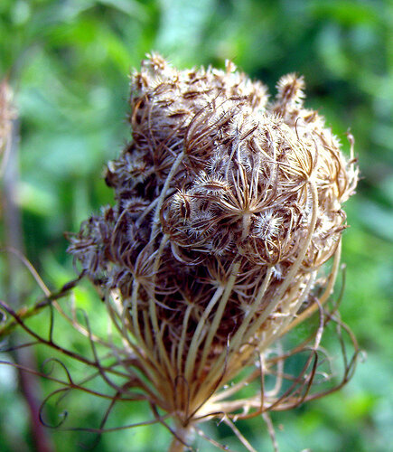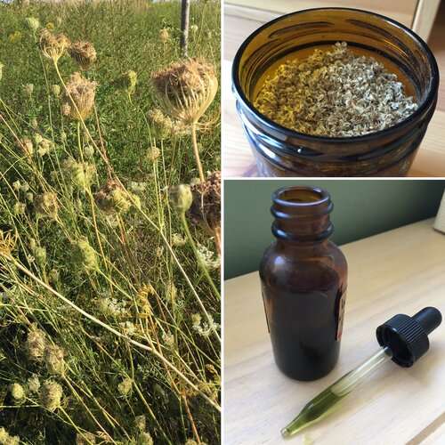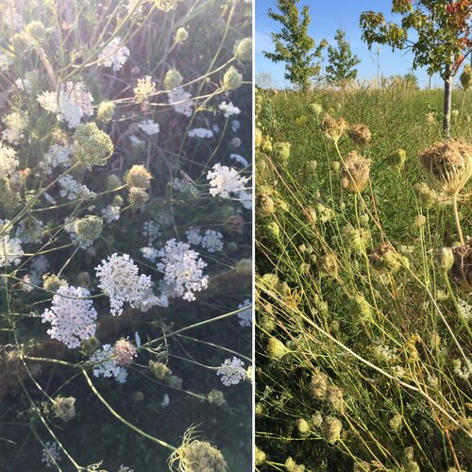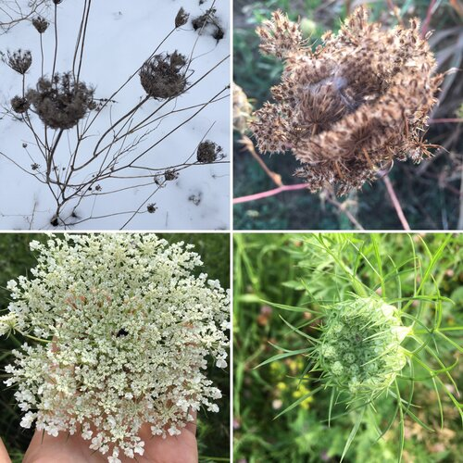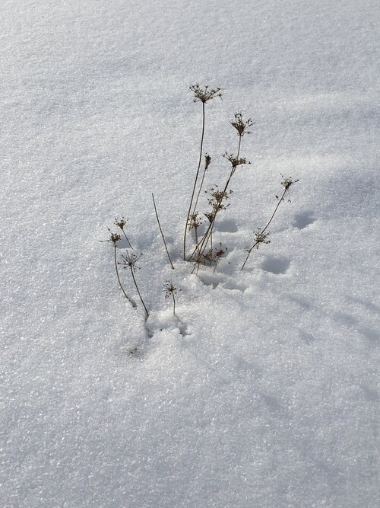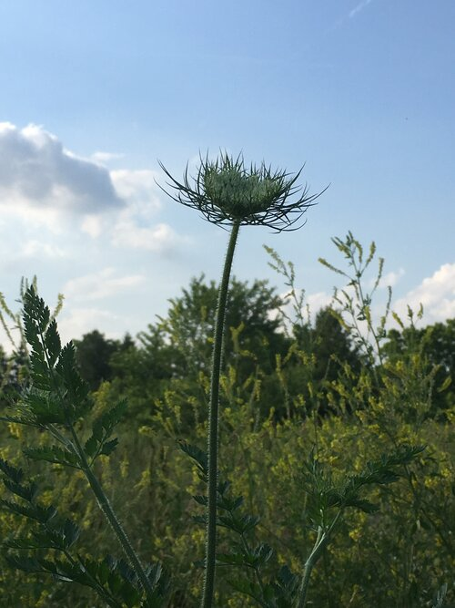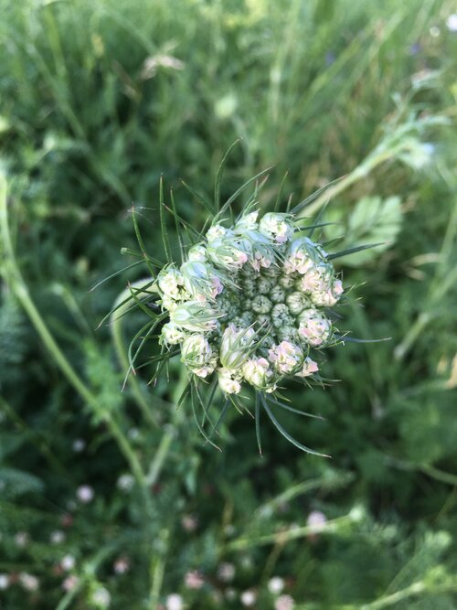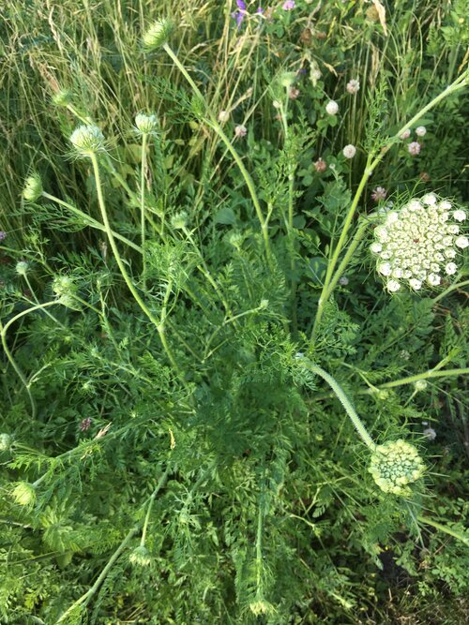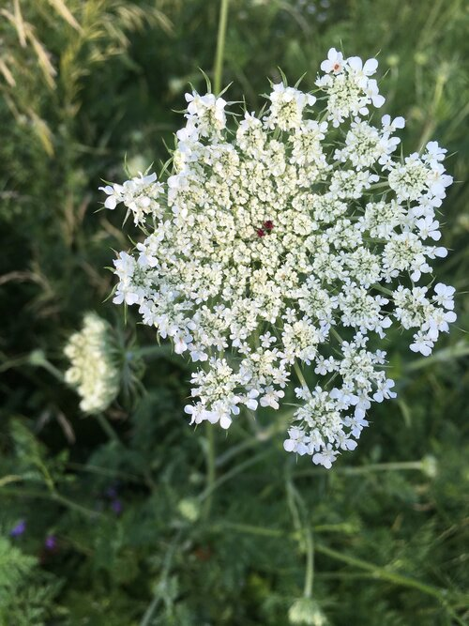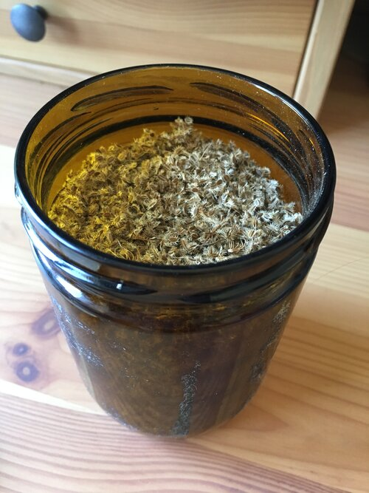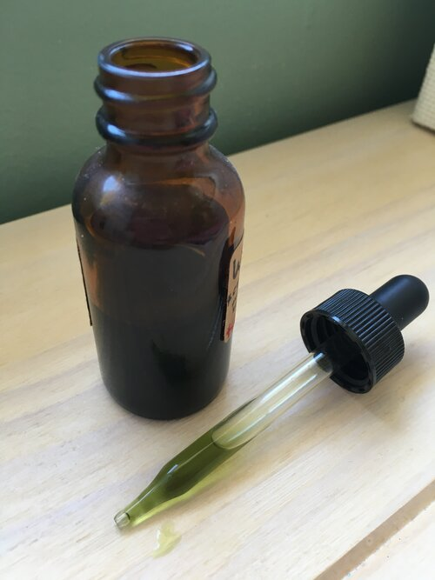

More specifically, Queen Anne’s Lace works as an **implantation inhibitor.** This means it prevents a fertilized egg from implanting and developing into a pregnancy.

Queen Anne's Lace is not a contraceptive (as it does not prevent ovulation, ejaculation, fertilization, or conception ). Nor is Queen Anne’s Lace an abortive (as it does not disrupt an early pregnancy that is already well established and healthy). Rather, it disrupts normal hormonal shifts in the body that would enhance and develop healthy endometrial lining for a pregnancy to implant. It makes the uterus inhospitable to grow a pregnancy.

I like to think of it as solely being a relationship with yourself. When taking Queen Anne’s Lace, we’re not endeavoring to affect a conception, a potential life. Rather, we are affecting our own bodies. We are withdrawing our consent to be a parent (at that time) and to grow a pregnancy. It’s personal, and it affects us, alone.

Working with Queen Anne's Lace, like working with all plant medicine, is an adventure in relationship, in self-awareness, and in imperfection.

There are very few scientific studies done on Queen Anne’s Lace, even fewer with humans participating, even fewer with standardized dosing and seeking specific information about effectiveness. Historical use, anecdotes, and small community studies give us a basic picture of what to expect when working with Queen Anne’s Lace.

[Small cohort studies](https://www.robinrosebennett.com/resources/wild-carrot-exploration-summary-august-2011) show 90-100% effectiveness with perfect use and perfect intention, with a few big disclaimers:

These studies were done on such small selections of populations they are not generalizable to people as a whole.

Plants, and people, come in huge varieties. Just because some small studies showed effects on some people with some Queen Anne’s Lace doesn’t mean you and the plants you’re working with will respond the same. Herbal medicine has so many variables it’s difficult (and some would say unethical) to bring it into the lab.

No matter how much we scientifically study menstruation, ovulation, conception, fertilization, implantation, herbalism, and more in a lab, we can never wholly understand the mystery. Even those with predictable cycles and impeccable fertility awareness can note times of unusual fertile symptoms, and unpredictable conceptions. Even with perfect science, human error exists!

That’s all a rambly disclaimer to say: nothing works perfectly for everyone. Proceed with your own levels of personal awareness and risk when working with your own fertility.

My second and biggest disclaimer is this:

The **most important** aspect of working with Queen Anne’s ace is learning to **identify it properly** and distinguish it from its many look-alikes. Why is this so important? Because some of its look-alike are poisonous and not for consumption even in small amounts. Do not work with this plant unless you are absolutely sure of your identification!

**Protocols and Dosages**

There is scientific disagreement as to whether Queen Anne’s Lace has primarily estrogenic properties, or if she works more with progesterone. There is also conflict as to whether the introduction or the withdrawal of Queen Anne’s Lace is the key to her efficacy, and what the ideal timing is.

What seems to be true is this: she is not a daily contraceptive, she needs to be introduced, and then withdrawn, surrounding a specific potentially fertilizing event, on a specific schedule.

Queen Anne’s Lace, in whatever manner who choose to work with it, should be used surrounding a potentially fertilizing event:

Optimally, in three doses:

1st dose: 8-12 hours surrounding potential fertilization

2nd dose: 8ish hours after the first dose

3rd dose: 8ish hours after send dose

Then stop.

These doses should be spaced over a minimum of 24 hours and an absolute maximum of 72 hours.

These doses should be based on potential fertilization (i.e. “unprotected” sex), NOT daily, NOT only at specific times of a cycle.

Doses can be any of the following (but should stay consistent. For example: If 1st dose is tincture, all doses should be tincture):

**Dried Seeds:**

Choose one of the following:

* About a teaspoon, chewed well and swallowed with juice/water on an empty stomach. This is the oldest historical method of consuming Queen Anne’s Lace for implantation inhibition.
* About a teaspoon, ground by mortar and pestle or clean coffee grinder, and mixed into a small amount of juice or water, taken on an empty stomach
* About a teaspoon, ground by mortar and pestle or clean coffee grinder, into a cup. Pour 8oz boiling water over, let steep for 15 minutes, consume on an empty stomach

**Dried Flowers:**

* Place 2-3 dried flower heads into a teacup. Pour 8oz boiling water over, let steep for 15 minutes, consume on an empty stomach

**Fresh Seeds:**

* Use in a tincture, as detailed below:

**Fresh Flowers:**

Choose one of the following:

* Place 3-6 fresh flower heads into a teacup. Pour 8oz boiling water over, let steep for 15 minutes, consume on an empty stomach

**Tincture:**

* 30-60 drops in a small glass with a few tablespoons of cool water taken on an empty stomach

For a much more detailed look into working with this lovely wildflower, check out my course on Queen Annes Lace, full of a deeper exploration into holistic fertility management, plant identification, medicine making, Queen Anne’s Lace habitat, uses, studies, links, teachers, and more.

[Queen Annes Lace for Fertility Management Online Course](https://www.mollyduttonkenny.com/online-workshops-store/queen-annes-lace-ecourse)

$29.00

(Approx. 2-3 hrs content) In this course we share wisdom regarding this remarkable wildflower and its properties for fertility management and implantation inhibition (“nature’s morning after pill”). We’ll learn all about Queen Anne’s Lace herself, about ethical harvest and medicine making, about dosing and preparations, and about other uses for the plant! An extensive Resources section is included. Course is broken down into mini-lessons for easy navigation, and features photos, videos, and written lessons.

Quantity:

Purchase

**APPENDIX**

**Exploring this herbal database can be fun.** I invite you to peruse and paste items from it into Google. The herbs cited hereafter are contraceptive, not abortificient nor emmenalogues

**Studies of Plants with Folkloric/Traditional Use to Regulate Fertility:**

[1] Aa paleacea (H.B.K.) Rchb. f. [Orchidaceae] Hierba de la soledad LF C, S Peru Rainer and Ashley (2010)

[4] Abuta grandiflora (Mart.) Sand. [Menispermaceae] Abuta RT, ST C Peru Rainer and Ashley (2010)

[5] Acacia farnesiana (L.) Willd. [Fabaceae] Fitnah FR, FL C Egypt Haggag (1989)

[6] Acacia leucophloea (Roxb.) Willd. [Fabaceae] Renjhua, Safed kikar BR, LF, GU C India Jain et al. (2004), Meena and Rao (2010)

[7] Acalypha grandis Benth. [Euphorbiaceae] Nomomp i naviag LF C Vanuatu Bourdy and Walter (1992)

[13] Achyranthes bidentata Blume. [Amaranthaceae] – LF, RT C India Paulsamy et al. (2007)

[23] Ailanthus excelsa Roxb. [Simaroubaceae] Ghar Karnana SB C India Tarafder (1983)

[32] Alstonia pacifica Seem. [Apocynaceae] – Sap C Vanuatu Bourdy and Walter (1992)

[34] Alstonia vitiensis Seem. var. neo-ebudica Monachino [Apocynaceae] Niete tel LF BU C Vanuatu Bourdy and Walter (1992)

[35] Alysicarpus vaginalis [Fabaceae] Davai RT C India Jain (2004

[37] Ambrosia arborecens Mill. [Asteraceae] Marco LF C Peru De-La-Cruz et al. (2007)

[39] Ambrosia elatior Linn. [Asteraceae] Altamisa LF,ST C Argentina Goleniowski et al. (2006)

[47] Anethum sowa Kurz. [Apiaceae] Soya FR C India Malhi and Trivedi (1972)

[56] Anthurium tessmannii [Araceae] – LF C Columbia Brondegaard (1973), Chaudhary (1966)

[65] Argyreia speciosa Sweet. [Convolvulaceae] Takoria alu TU C India Sikdar and Datta (2008)

[66] Argyrochosma nivea (Poir.) Windham [Pteridaceae] Culandrillo PL C Argentina Trillo et al. (2010)

[67] Arisaema atrorubens [Araceae] – RH C Canada Brondegaard (1973)

[68] Arisaema leschenaultii [Araceae] – TU, SP C India Paulsamy et al. (2007)

[69] Arisaema tortuosum Wall. Schott [Araceae] – TU, SP C India [

70] Arisaema triphyllum Torr. [Araceae] RT C United States Brondegaard (1973), Farnsworth et al. (1975)

73] Aristolochia clematitis Linn. [Aristolochiaceae] – SD C Hungary Brondegaard (1973), Farnsworth et al. (1975)

[80] Artemisia vulgaris Linn. [Asteraceae] Nagadouna LF, RT C India Ghosh (2008)

82] Asarum canadense Linn. [Aristolochiaceae] – RT, RH C North America Brondegaard (1973), Farnsworth et al. (1975

[83] Asclepias hallii A. Gray [Asclepiadaceae] – PL C United States Brondegaard (1973), Farnsworth et al. (1975

[84] Asclepias syriaca Linn. [Asclepiadaceae] – RT, RH C Canada Brondegaard (1973), Farnsworth et al. (1975)

[85] Asparagus acutifolia Linn. [Liliaceae] – FR C Europe Brondegaard (1973), Farnsworth et al. (1975)

[86] Asparagus officinalis Linn. [Liliaceae] Halyun FR C Europe Brondegaard (1973), Farnsworth et al. (1975)

[88] Aspidosperma quebracho-blanco Schltdl. [Apocynaceae] Quebracho blanco LF C Argentina Trillo et al. (2010)

[89] Asplenium adiantum-nigrum Linn. [Polypodiaceae] Black Spleen Wort PL C India Brondegaard (1973), Chopra et al. (1958), Kirtikar and Basu (1946), De Laszlo and Henshaw (1954

[90] Asplenium nidus Linn. [Aspleniaceae] – LF C Vanautu Bourdy and Walter (1992

[91] Atractylis gummifera Linn. [Asteraceae] – RT C Arabia Brondegaard (1973)

[94] Azadirachta indica A. Juss. [Meliaceae] Neem GU C India Kirtikar and Basu (1946), Nadkarni (1976), Satyavati et al. (1976) Dadarek FR C Pakistan Shah et al. (2009)

[96] Bahia dissecta (A. Gray) Britton [Asteraceae] – RT C United States Brondegaard (1973), Farnsworth et al. (1975)

[99] Barringtonia edulis Seem. [Lecythidaceae] Butsu vel SB C Vanautu Bourdy and Walter (1992)

[113] Borassus flabellifer Linn. [Arecaceae] Tad RT C India Jain et al. (2004)

[116] Brassica indica [Brassicaceae] Kadugu SD C India Priya et al. (2002)

[122] Bridelia retusa (L.) Spreng. [Euphorbiaceae] Lankpana BR C India Jain et al. (2004)

[125] Bulbostylis capillaris (L.) Clarke [Cyperaceae] Bulbostylis LF, ST C Argentina Goleniowski et al. (2006)

[126] Bursera simaruba (L.)Sarg. [Burseraceae] – BR C Panama Gupta et al. (2005)

[131] Caladium seguinium (Jacq.) Vent. [Araceae] – PL C South America, Germany,India Dvorjetski (1958), Farnsworth et al. (1975)

[133] Callicarpa macrophylla Vahl. [Verbenaceae] Daya – C India De Laszlo and Henshaw (1954)

[134] Callicarpa sp. [Verbenaceae] – LF C Torres-Straits Brondegaard (1973), Farnsworth et al. (1975)

[137] Camptosema paraguariense var. Parviflorum Hassl. [Fabaceae] Akt’atet echei LF, RT C Paraguay Arenas and Azorero (1977)

[141] Careya arborea Roxb. [Lecythidaceae] Pizh FB C India Priya et al. (2002)

[149] Cassia lanceolata Linn. & Forsk. [Fabaceae] Sana LF C India Chopra et al. (1958), Kirtikar and Basu (1946), Nadkarni (1976)

[150] Cassia occidentalis Linn. [Fabaceae] Kasondi RT C India Badami et al. (2003)

[151] Castilleja angustifolia [Scrophulariaceae] – – C United States Brondegaard (1973), Farnsworth et al. (1975)

[152] Casurina equisetifolia J.R. et G.Forst. [Casuarinaceae] Niyar, Yorset SB, LF C Vanautu Bourdy and Walter (1992)

[153] Catasetum fimbriatum Lindl. [Orchidaceae] Poha marangatu Bu C Paraguay Arenas and Azorero (1977)

[155] Cayratia trifolia Domin. [Vitiaceae] Nagamat nding-nding FR C Vanautu Bourdy and Walter (1992)

[168] Chenopodium ambrosioides L. [Chenopodiaceae] Paico or Pazote PL A, E Central and South America Curtin (1965)

[169] Chenopodium botrys Linn. [Chenopodiaceae] Jeruselum oak LF E Massachusettes Williams (1819)

[174] Chusquea ramosissima Lindm. [Poaceae] – YS C Paraguay Brondegaard (1973

[177] Cicuta maculata Linn. [Apiaceae] – RT C United States Brondegaard (1973), Farnsworth et al. (1975)

[178] Cienfuegosia drummondii Lewton [Malvaceae] Rituremich RT C Paraguay Arenas and Azorero (1977)

[185] Citrus bergamia Risso [Rutaceae] Bergamotto – C Italy Passalacqua et al. (2007)

[188] Clobba marantia [Zingiberaceae] – – C Melanesia, Gunantuna Brondegaard (1973)

[189] Cnicus benedictus [Asteraceae] – PL C North America Farnsworth et al. (1975

[190] Cocos nucifera Linn. [Arecaceae] Nariyal SD C Java Brondegaard (1973)

[191] Codiaeum variegatum (L.) Bl. [Euphorbiaceae] Inloptahow PL A Vanautu Bourdy and Walter (1992) Croton LF C Papua New Guinea WHO (2009)

[192] Coffea Arabica L. [Rubiaceae] Caffè BE A Italy Savo et al. (2011)

[193] Coix lacryma-jobi L. [Poaceae] Ooína SD A, E Korea Woo et al. (1981)

[194] Commelina erecta Linn. [Commelinaceae] Ja Pininguí PX C Paraguay Arenas and Azorero (1977)

[199] Cordia quarensis Gürke [Boraginaceae] Kano RT C Africa Farnsworth et al. (1975), De Laszlo and Henshaw (1954)

[209] Croton tiglium Linn. [Euphorbiaceae] Croton oil plant RT, SD A Africa Burkill, 1985a

[212] Curarea tecunarum Barneby & Krukoff [Menispermaceae] Bekú ST C Brazil Lewalle and Rodegem (1968)

[216] Cuscuta sp. (Tourn.) Linn. [Convolvulaceae] – PL C United States Brondegaard (1973)

[221] Cyperus redolens Maury [Cyperaceae] Mooti poec coc RT C Paraguay Arenas and Azorero (1977)

[225] Datura metel Linn. [Solanaceae] Sadahdhatura LF, FR, RT C India Malhi and Trivedi (1972), Priya et al. (2002)

[231] Dieffenbachia sequine (Jack) Schott [Araceae] – LF, ST C Cuba, Dominican Puerto Rico, Republic Santa Lucia Brondegaard (1973), Duke (1988), Dvorjetski (1958)

[232] Dioscorea composita (Hemsl.) [Dioscoreaceae] Barbasco TU C Indio’s American Duke (1988)

[233] Dioscorea pentaphylla Linn. [Dioscoreaceae] Lalvala vahrikand TU C India Jain et al. (2005)

[234] Dioscorea sativa Thunb. [Dioscoreaceae] Ratalu TU C Australia Farnsworth et al. (1975)

[239] Duckesia verrucosa (Ducke) Cuatrec. [Humiriaceae] Uchi-corôa SD C Brazil Rodrigues (2007)

[240] Dryopteris felix-mas (Linn.) Schott [Polypodiaceae] Male fern RT, SD C Europe, India Farnsworth et al. (1975), Nadkarni (1976)

[241] Dryopteris normalis C. Chr. [Polypodiaceae] Fern(Helecho macho) – C Mexico Latorre and Latorre (1977)

[245] Ehretia cymosa Thonn. [Boraginaceae] Jaoke LF, BR C Nigeria Leni (2009)

[247] Embelia ribes Burm. f. [Myrsinaceae] Baberang RT C India Kirtikar and Basu (1946), Malhi and Trivedi (1972), Nadkarni (1976), Satyavati et al. (1976)

[249] Entada scandens Benth. [Fabaceae] – SD C Australia Brondegaard (1973), Farnsworth et al. (1975)

[250] Epimedium alpinum Linn. [Berberidaceae] – LF, RT C Europe Farnsworth et al. (1975)

[252] Eriogonum jamesii Benth. [Polygonaceae] – RT C United States Brondegaard (1973), Farnsworth et al. (1975)

[259] Euodia elleryana F. Muell. [Rutaceae] Kurih, Sehit BR C Papua New Guinea WHO (2009)

[260] Eupatoriun odoratum Linn. [Asteraceae] Assam lota RT C Central America Farnsworth et al. (1975) – PL E India Kirtikar and Basu (1946) 10 D. Kumar et al. / Journal of Ethnopharmacology 140 (2012) 1–32 Table 1 (Continued) S. no. Plant name with family Common name Part used* Traditional use† Country References

[261] Eupatoriun squalidum DC. [Asteraceae] – IF C Paraguay Arenas and Azorero (1977)

[270] Ficus religosa Linn. [Moraceae] Peeple FR C Pakistan Shah et al. (2009)

[271] Ficus wassa Roxb. [Moraceae] Avavaia, Gabajekni RT C Papua New Guinea WHO (2009)

[272] Flagellaria indica Linn. [Flagellariaceae] Narakpui LF C Vanautu Bourdy and Walter (1992)

[273] Flemingia strobilifera (L.) J. St.-Hil Syn. Moghania strobilifera (L.) J. St.-Hil. [Fabaceae] Arana SD C Papua New Guinea WHO (2009)

[278] Franseria artemisioides Willd. [Asteraceae] – PL C Colombia Brondegaard (1973)

[284] Glochidon sp. [Euphorbiaceae] Namlahow LF C Vanautu Bourdy and Walter (1992)

[285] Glandularia platensis (Spreng.) Schnack & Covas [Verbenaceae] Verbena blanca LF C Argentina Goleniowski et al. (2006)

[290] Gossypium herbaceum Linn. [Malvaceae] Kapas RT C India, South America Brondegaard (1973), Kirtikar and Basu (1946), Nadkarni (1976), Farnsworth et al. (1975)

[298] Hedera helix Linn. [Araliaceae] Banda FR C Mediterranean Brondegaard (1973), Farnsworth et al. (1975) D. Kumar et al. / Journal of Ethnopharmacology 140 (2012) 1–32 11 Table 1 (Continued) S. no. Plant name with family Common name Part used* Traditional use† Country References

[303] Hibiscus tiliaceus Linn. [Malvaceae] – FL C Melanesia, Gunantuna Brondegaard (1973)

[305] Homalanthus novoguineensis (Warb.) K. Schum. [Euphorbiaceae] Ngohou LF C Papua New Guinea WHO (1999)

[306] Huperzia saururus (Lam.) Trevis. [Lycopodiaceae] Cola de quirquincho PL C Argentina Trillo et al. (2010)

[308] Hymenaea stigonocarpa Mart. ex Hayne [Fabaceae] Pojkôré BR C Brazil Rodrigues (2007)

[310] Hypochoeris brasiliensis (Less.) Benth. Chicoria LF, RT C Paraguay Hirschmann and Bordas (1990)

[313] Indigofera linnaei Ali [Fabaceae] Tejomala RT C India Jain (2004)

[314] Jacaranda copaia (Aublet.) D. Don. [Bignoniaceae] Murupá TU C Brazil Rodrigues (2007)

[317] Juglans regia Linn. [Juglandaceae] – LF C Slovakia Brondegaard (1973)

[318] Juniperus communis Linn. [Cupressaceae] Aaraar PX, ST, FR C, E India Kirtikar and Basu (2003),

[321] Justicia simplex D. Don Justicia japonica Thunb. [Acanthaceae] – RT C India Badami et al. (2003), Kirtikar and Basu (1946), Nadkarni (1976)

[322] Kopsia sp. [Apocynaceae] Somu LF C Vanautu Bourdy and Walter (1992) [323] Lagenaria siceraria Standl. Syn. L. vulgaris [Cucurbitaceae] Kashiphal FR, SD E India Malhi and Trivedi (1972)

[326] Leonotis nepetaefolia R.Br. [Labiatae] Pick Nut LF A Jamaica Asprey and Thornton (1955)

[328] Licuala sp. [Arecaceae] Solomon RB C Islands (Buka) Brondegaard (1973)

[332] Lithospermum officinale Linn. [Boraginaceae] Lubis firmun RT C United States Brondegaard (1973)

[333] Lithospermum ruderale [Boraginaceae] – RT C United States Brondegaard (1973), Farnsworth et al. (1975), Xu et al. (1987a,b)

[334] Lobelia nicotianifolia Heyne [Campanulaceae] Nala PL C Indian Satyavati et al. (1987)

[335] Lonicera ciliosa [Caprifoliaceae] – LF C United States Brondegaard (1973) 12 D. Kumar et al. / Journal of Ethnopharmacology 140 (2012) 1–32 Table 1 (Continued) S. no. Plant name with family Common name Part used* Traditional use† Country References

[338] Lycopodium annotinum Linn. [Lycopodiaceae] – PL C Soviet Union Brondegaard (1973)

[341] Lygodium dichotomum Sw. [Schizaeaceae] – RT C Buka Islands Brondegaard (1973), Farnsworth et al. (1975)

[342] Mallotus philippinensis Muell. Arg. [Euphorbiaceae] Kamila FR C India Malhi and Trivedi (1972), Satyavati et al. (1987)

[343] Mallotus sp. [Euphorbiaceae] – RT C Oceania (Buka) Brondegaard (1973), Farnsworth et al. (1975) )

[349] Maytenus ilicifolia Mart. [Celastraceae] Yvyra rapo ju LF, RT C Paraguay Arenas and Azorero (1977)

Srivastava (2005)

[351] Melia azadirachta Linn. [Malvaceae] Bakain FL, LF, RE C India Chopra et al. (1958), Kirtikar and Basu (1946), Nadkarni (1976)

[352] Melochia hermannioides Saint. Hill. [Sterculaceae] – RT C Paraguay Arenas and Azorero (1977))

Shah et al. (2009)

[355] Mentha longifolia Linn. [Labiateae] Wild Pudina LF C Pakistan Shah et al. (2009)

[357] Mesua ferrea Linn. [Clusiaceae] Nagkesar LF C India Kirtikar and Basu (1946), Nadkarni (1976)

[362] Mimosa pudica Linn. [Fabaceae] Lajwanti RT C India Tiwari et al. (1982) [363] Mitragyna parvifolia (Roxb.) Korth. [Rubiaceae] Kadam BR C India Jain (1991) [364] Mollugo cerviana Ser. [Ficoidaceae] – FL E India Satyavati et al. (1987)

[372] Mouriri pusa Gardner [Melastomataceae] Krohtot BR, LF C Brazil Rodrigues (2007)

[374] Musa sapientum L.Syn. M. paradisiacal auct. [Musaceae] Banana ST, FL A India Maheshwari et al. (1986), Sharma (1981) Muzi RT A Ethopia Abbink (2002

[376] Nepeta cataria Linn. [Labiateae] Badbudar PL C Pakistan Shah et al. (2009)

[377] Nardostachys gradiflora DC. [Valerianaceae] Masi ST C India Gangwar et al. (2010)

[380] Nasturtium officinalis R.Br. [Brassicaceae] Tara Mira PL A Pakistan Shah et al. (2009

[383] Nicotiana tabaccum Linn. [Solanaceae] Taako LF A Cameroon Emmanuel and Claidette (2007)

[386] Nothocnide repanda (Bl.) Bl. [Urticaceae] Rawe mandisi LF A Vanautu Bourdy and Walter (1992)

[387] Ocimum basilicum Linn. [Labiatae] Babuitulsi LF C Gunantuna Brondegaard (1973) [388] Olea europea Linn. [Oleaceae] Aulivo LF A Italy Savo et al. (2011

[395] Paeonia officinalis Linn. [Ranunculaceae] – – C Soviet Union Brondegaard (1973) [396] Pandanus odoratissimus L.f. [Pandanaceae] Kevera RT, IF A India Jain (1991)

(1954) Pandanus SB C Vanautu Bourdy and Walter (1992)

[408] Philodendron dyscarpium R.E. Schult. [Araceae] – LF C Columbia Brondegaard (1973), Chaudhary (1966) [409] Phlox stansburyi (Torr.) A. Heller [Polemoniaceae] – LF C United States Brondegaard (1973)

[410] Phoradendron macrophyllum (Engelm.) Kokerell [Loranthaceae] Big leaf Mistletoe – C California Adams and Garcia (2006)

[411] Phyllantus ciccoides M.A. [Euphorbiaceae] Fonfati SB C Vanautu Bourdy and Walter (1992)

[414] Physalis minima Linn. [Solanaceae] Tulatipati PX C India Satyavati et al. (1987)

417] Piliostigma thonningii (Schum.) Milne-Redh. [Fabaceae] – RT C East Africa Brondegaard (1973)

[418] Pipturus argenteus (Forst. F.) Wedd. [Urticaceae] Dame SB C Vanautu Bourdy and Walter (1992)

[420] Pisum sativum Linn. [Fabaceae] Mattar SD C India De Laszlo and Henshaw (1954), Satyavati et al. (1987)

[423] Pleioceras barteri Baill. [Apocynaceae] Pariomo da LF, RT A, E Nigeria Aladesanmi et al. (2007)

ta Ait. Syn. P. acutifolia Poir. [Apocynaceae] Gobarchampa RT A India Nadkarni (1976), Tarafder (1983)

[428] Pneumatopteris glandulifera (Brackeneridge) Holtt. [Thelypteridaceae] Wutubo LF C Vanautu Bourdy and Walter (1992)

[429] Polygala monyicola var. brizoides Steyerm [Polygalaceae] – PL C China Elisabetsky and Posey (1989)

[430] Polygala longicaulis H.B.K. [Polygalaceae] – FL, SD C China Elisabetsky and Posey (1989)

[432] Populus alba Linn. [Salicaceae] – SB C Mediterranean Brondegaard (1973), Farnsworth et al. (1975)

[433] Pouzolzia hypoleuca Wedd. [Urticaceae] Soap brush RT C Zimbabwe Sewani-Rusike (2010) )

[436] Prosopis algarobilla Griseb. [Fabaceae] – RT C South America Brondegaard (1973) RT, FR S, A India Meena and Rao, 2010

[439] Prunus emarginata [Rosaceae] – WD C United States Brondegaard (1973))

umbelliferum Boiss. [Asteraceae] Mithaakarkara RT A India

[449] Pyrrosia confluens (R.Br.) Ching [Polypodiaceae] Natali nin nanui ST C Vanautu Bourdy and Walter (1992)

[457] Rosmarinus officinalis Linn. [Labiatae] – PL C Central America Brondegaard (1973), Farnsworth et al. (1975)

[459] Rhus trilobata Nutt. [Anacardiaceae] – LF C United States Brondegaard (1973)

[460] Rhynchospora cephalotes (L.) Vahl [Cyperaceae] Caparé RT C Brazil Rodrigues (2007)

[463] Ricinus communis Linn. [Euphorbiaceae] Arand SD C Pakistan Shah et al. (2009)

[464] Rivea hypocrateriformis Choisy. [Convolvulaceae] – PX C India Shivalingappa et al. (2001)))

[476] Salsola sp. [Chenopodiaceae] – LF C Algiers Brondegaard (1973)

[481] Scaevola sericea Vahl. [Goodeniaceae] Negeelao LF C Vanautu Bourdy and Walter (1992)

[484] Sclerolobium aureum (Tul.) Baill. [Fabaceae] Tatarema BR C Brazil Rodrigues (2007)[486] Siegesbeckia orientalis L. [Asteraceae] Herbe á Flacq LF E Mauritius Sussman (1980)

[493] Semecarpus stellata Linn. [Anacardiaceae] – RT C India Brondegaard (1973)

[497] Smilacina stellata [Liliaceae] – RT, LF C United States Brondegaard (1973), Farnsworth et al. (1975))

[500] Solanum incanum L. Syn. Solanum sanctum L. [Solanaceae] Bitter apple FR C India, Nigeria Duke (2008)

[502] Sporobolus indicus (L.) Brong. [Poaceae] Esporobolo LF C Argentina Goleniowski et al. (2006)

[505] Sphaeralcea munroana (Douglas) Spanch. [Malvaceae] – RT C United States Brondegaard (1973)

[509] Stemodia ericifolia K. Schum. [Scrophulariaceae] Muiãhã PL C Paraguay Arenas and Azorero (1977

[510] Stevia rebaudiana [Asteraceae] – LF, ST C Paraguay Brondegaard (1973)

[512] Stenomesson variegatum [Amaryllidaceae] – – C South America Brondegaard (1973)

[517] Syagrus petraea (Mart.) Becc. [Arecaceae] Ac¸ aí-bravo FR C Brazil Rodrigues (2007) [523] Taxus wallichiana Zucc. [Taxaceae] Barmi LF A Pakistan Shah et al. (2009

[527] Thelypteris cf. scalaris (Christ.) Alton [Thelypteridaceae] Helecho Macho PL C Peru Rainer and Ashley (2010)

and Mukharjee (2009)

[529] Thysanolaena (Roxb.) O. Kuntze [Poaceae] Kutcho FL C India Maity et al. (2004)

[530] Tillandsia decomposita Baker [Bromeliaceae] – FS C South America Brondegaard (19

[539] Trichosanthes tricuspidata Lour. [Cucurbitaceae] Kaundal SD C India Kamble et al. (2010)

[546] Urena lobata Linn. [Malvaceae] Bachata LF C India, New Ireland Brondegaard (1973), Farnsworth et al. (1975), Kirtikar and Basu (1946)

[549] Urospatha antisylleptica [Araceae] – SP C Columbia Brondegaard (1973), Chaudhary (1966)

[551] Ventilago neo-caledonica schlecht. [Rhamnaceae] Labalaba LF C Vanautu Bourdy and Walter (1992)

[552] Veratrum californicum [Liliaceae] – RT C United States Brondegaard (1973)

[557] Viburnum prunifolium Linn. [Caprifoliaceae] – – C Italy Brondegaard, 1973, Farnsworth et al. (1975)

[559] Vigna phaseoloides Baker [Fabaceae] – RT C East Africa Brondegaard (1973)

[563] Vitex lagundi [Verbenaceae] – RT C Kurtachi, North Bougainvile Brondegaard (1973)

[571] Xanthium spinosum Linn. [Asteraceae] Spiny cocklebur LF C Spain Duke (2008

[577] Zizyphus xylopyrus (Retz.) Willd. [Rhamnaceae] Ghatoor FR C India Jain et al. (2004) *

1. https://wellwisp.com/does-adrenal-glands-produce-estrogen/
2. https://www.webmd.com/drugs/2/drug-20860/remifemin-menopause-oral/details
3. https://foodforbreastcancer.com/foods/blueberries
4. https://pmc.ncbi.nlm.nih.gov/articles/PMC7998294/
5. https://pubmed.ncbi.nlm.nih.gov/36379313/
6. https://www.mindbodygreen.com/articles/how-to-use-brazil-nuts-as-a-selenium-supplement
7. 1. AP (August 20, 2004). [*"Japanese Women Shun The Pill"*](https://www.cbsnews.com/news/japanese-women-shun-the-pill/). HealthWatch. CBS News*. Retrieved 2006-08-23*.

  
8. 1. "Infanticide in Japan: Sign of the Times?". *The New York Times*. 8 December 1973. Archivedfrom the original on 3 March 2018. Retrieved 1 September 2017.

  
9. https://www.ncbi.nlm.nih.gov/books/NBK402326/
10. 1. Norgren, Tiana (2001). Abortion Before Birth Control: The Politics of Reproduction in Postwar Japan. Princeton University Press. pp. *128–*130. [*ISBN*](https://en.wikipedia.org/wiki/ISBN_(identifier)) [*0691070040*](https://en.wikipedia.org/wiki/Special:BookSources/0691070040).

   
11. https://www.whiterabbitinstituteofhealing.com/herbs/Trichosanthes/
12. 1. [*"High abortion rate triggers fears for young women"*](https://web.archive.org/web/20220426185309/http:/www.chinadaily.com.cn/china/2015-01/27/content_19412949.htm). [*China Daily*](https://en.wikipedia.org/wiki/China_Daily). 2022-04-26. Archived from [*the original*](http://www.chinadaily.com.cn/china/2015-01/27/content_19412949.htm) on 2022-04-26*. Retrieved 2022-06-29*.

   
13. https://www.ft.com/content/6724580a-8d64-11e2-82d2-00144feabdc0
14. https://warroom.org/
15. https://en.wikipedia.org/wiki/Islam_and_abortion
16. https://www.europeana.eu/en/exhibitions/the-pill/contraception-in-ancient-history
17. https://shunchild.com/article/does-copper-prevent-pregnancy
18. https://www.mentalfloss.com/article/83685/9-forms-birth-control-used-ancient-world
19. https://www.cdc.gov/contraception/about/index.html
20. # Potential antifertility agents from plants: A comprehensive review

    ## Author links open overlay panelDinesh Kumar, Ajay Kumar, Om Prakash, J[ournal of Ethnopharmacology](https://www.sciencedirect.com/journal/journal-of-ethnopharmacology), [Volume 140, Issue 1](https://www.sciencedirect.com/journal/journal-of-ethnopharmacology/vol/140/issue/1), 6 March 2012, Pages 1-32

   
21. *Artemisia vulgaris* Linn: an updated review on its multiple biological activities

    [Deepali Siwan](https://fjps.springeropen.com/articles/10.1186/s43094-022-00436-2#auth-Deepali-Siwan-Aff1),

    [Dipali Nandave](https://fjps.springeropen.com/articles/10.1186/s43094-022-00436-2#auth-Dipali-Nandave-Aff2) &

    [Mukesh Nandave](javascript:;)

    [*Future Journal of Pharmaceutical Sciences*](https://fjps.springeropen.com/)